* What is the name of your business?

Pixel Tek Studios

* Who will be the users of the system (managers, employees, customers)?

Customers

* What product(s) and or service(s) does it sell? Be specific.

Pixel Tek Studios will develop and sell a variety of indie style software/games.

* Who are the customers? What is the customer base?

The focus consumer group for Pixel Tek Studios products will be gamers ranging in the age group of young adult to adults.

* What sales and distribution channels are used?

The software will primarily be available through digital distribution this includes online retail stores (IE Steam, GOG, or Desura) as well as the company website that will provide product codes to be redeemed on said online retail stores.

* How are payments made?

Payments are made only through digital purchases, including debit/credit purchases or through online payment services (IE Paypal)

* Are products delivered or shipped to customers in some way?

Products are only delivered digitally to be downloaded to the preferred device of the customers choosing. There will be no physical copies of any software available unless special events require it.

* Are sales reps involved? Are they paid on commission?

As all the products are sold through a third party service (IE Steam) they will take a percentage of each sale determined by the third party.

* What type of reports are needed by the business?

Customer and professional reviews are the most important reports in order for the business to be successful. If the reviews are bad, the sales will decrease proportionately based on the negative reviews.

Sales documents are also very important, the company has to keep very strict watch on their sales and budget.

ERD:

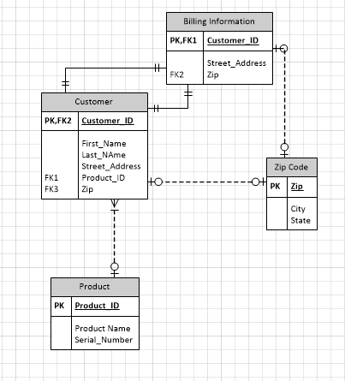

|  |  |  |  |  |  |  |  |
| --- | --- | --- | --- | --- | --- | --- | --- |
| Table Name | Column Name | Description of Data | Data Type | Length | Not Null | PK | FK |
|  |  |  |  |  |  |  |  |
| **Customer Information** |  |  |  |  |  |  |  |
|  | Customer_ID | Id number | integer | 10 |  | y |  |
|  | First_Name | First name | varchar | 25 | y |  |  |
|  | Last_Name | Last name | varchar | 25 | y |  |  |
|  | Street_Address | Primary address | varchar | 50 |  |  |  |
|  | Zip | Zip code | integer | 11 |  |  | y |
|  | Product_ID |  |  |  |  |  |  |
|  |  |  |  |  |  |  |  |
|  |  |  |  |  |  |  |  |
| **Zip Code** |  |  |  |  |  |  |  |
|  | Zip | Zip code | integer | 11 |  | y |  |
|  | City | city name | varchar | 25 | y |  |  |
|  | State | State name | varchar | 25 | y |  |  |
|  |  |  |  |  |  |  |  |
| **Product** |  |  |  |  |  |  |  |
|  | Product_ID | ID of software available for sale | integer | 10 |  | y |  |
|  | Serial_Number | Serial number for individual sofware | integer | 8 | y |  |  |
|  | Product_Name | Name of software |  |  |  |  |  |
|  |  |  |  |  |  |  |  |
|  |  |  |  |  |  |  |  |
| **Billing Information** |  |  |  |  |  |  |  |
|  | Customer_ID | Id number | integer | 10 |  | y | y |
|  | Street_Address | Primary address | varchar | 50 | y |  |  |
|  | Zip | Zip code | integer | 11 | y |  | y |

Data Dictionary: